Consultant Roster guidance

Step 1: You log into this website: http://www.unfpa.org/unfpa-consultant-roster
Step 2: Click on ‘’registering and creating profile for the first time’’
Step 3: You will get this screenshot then click on ‘’apply now’’ for the consultant roster

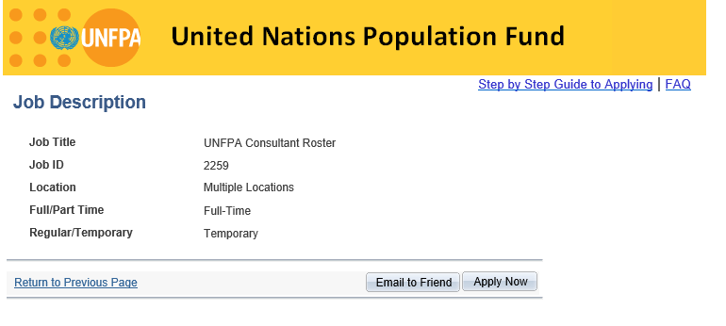
Step 4: Click on ‘’click her to register’’
Step 5: click on ‘’I agree’’ and ‘’continue’’
Step 6: Complete your personal information and click on ‘’save’’ and then ‘’continue’’
Step 7: Enter all the information required and then click on ‘’save’’ and then ‘’submit’’

This is it then you will receive a notification that your application is successful.

