Date: 24 January, 2022

REQUEST FOR QUOTATION

RFQ Nº UNFPA/FJI/RFQ/22/001

Dear Sir/Madam,

UNFPA hereby solicits a quotation for the following item: **10 sets x Reproductive Health Tent (RH TENT) SIZE 6X12 Meter**

|  |  |
| --- | --- |
| **Technical Specification** | |
|  | |
| **TENT ROOF** | |
| Outside | : White Color |
| Inside | : Grey/navy blue/similar |
| Coating Technique | : Triple Coating |
| Coating | : to reduce solar heat, water resistant and anti-fungi |
| Chemical Coating Material | |
| Coating Material | : Standard ISO 9001-2008/OEKOTEX |
| Type of polyester | : 100% 450 D |
| Raw Material of yarn | : New material Grade A (not recycle) |
| Finishing of Yarn | : Military Standard |
| Twist system, light and strong | |
|  | |
| **PLAFON TENDA** | |
| Ceiling Material | : Satin Polyester, Full tent ceiling |
|  | |
| Print logo **UNFPA and DFAT** above the front and rear entrances. | |
|  | |
|  | |
| **MAIN FRAME** | |
| Material | : Black Pipe/Galvanized or equivalent and coating |
| Load resistance | : Not easy to break/crack |
| Pipe type | : Unreinforced pipe |
| Construction | |
| a. Main Pipe (pole) | : Pipe |
| - Diameter,mm | : 45 |
| - Thickness,mm | : 1.2 |
| - Length (main pole),mm | : 1800 |
| - Quantity,bar | : 14 |
| b. Base pipe | |
| - Outside Diameter, mm | : 45 |
| - Thick, mm | : 1.2 |
| - Length, mm | : 1800 |
| - Quantity, bar | : 12 |
| c. Connecting of Main Pole | |
| - Outside Diameter, mm | : 40 |
| - Thick, mm | : 1.2 |
| - Length, mm | : 1800 |

|  |  |  |
| --- | --- | --- |
| **Technical Specification** | | |
| - Quantity, bar | : | 12 |
| d. Roof Frame, Curved Pipe | | |
| - Outside Diameter, mm | : | 40 |
| - Thick, mm | : | 1.2 |
| - Length, mm | : | 2800 |
| - Quantity, bar | : | 21 |
| e. Roof Connecting Pipe | | |
| - Outside Diameter, mm | : | 40 |
| - Thick, mm | : | 1.2 |
| - Length, mm | : | 1900 |
| - Quantity, bar | : | 54 |
| f. Connector, L type (Edge Base) | | |
| - Outside Diameter, mm | : | 45 |
| - Thick, mm | : | 1.2 |
| - Whole pipe length, mm | : | 400 |
| - Outside pipe length, mm | : | 100 X 2 |
| - Inlet pipe length, mm | : | 100 X 2 |
| - Quantity, socket | : | 4 |
| g. Connector, T type | | |
| - Outside Diameter, mm | : | 45 |
| - Thick, mm | : | 1.2 |
| - Whole pipe length, mm | : | 600 |
| - Outside pipe length, mm | : | 100 X 3 |
| - Inlet pipe length, mm | : | 100 X 3 |
| - Quantity, socket | : | 6 |
| h. Connector, Y type (Edge Roof Frame) | | |
| ( Kaki Tiga ) | | |
| - Outside Diameter, mm | : | 40 |
| - Thick, mm | : | 1.2 |
| - Whole pipe length, mm | : | 900 |
| - Outside pipe length, mm | : | 100 X 4 |
| - Inlet pipe length, mm | : | 100 X 3 |
| - Quantity, socket | : | 4 |
| i. Middle roof truss (Four Legs) | | |
| - Outside Diameter, mm | : | 40 |
| - Thick, mm | : | 1.2 |
| - Whole pipe length, mm | : | 900 |
| - Outside pipe length, mm | : | 100 X 4 |
| - Inlet pipe length, mm | : | 100 X 3 |
| - Quantity, socket | : | 10 |
| **PEGS** | | |
| Fishing rod type | | |
| Material | : | Steel Concrete |
| Basic Shape | : | Round |
| Construction | | |
| a. Diameter, mm | : | 8 |
| b. Length, mm | : | 300 |
| c. Part of bends, mm | : | 50 |
| d. Straight part | : | 250 |
| U Shape | | |
| Material | : | Steel Concrete |
| Design | : | Round |
| a. Diameter, mm | : | 12 |
| b. Length, mm | : | 500 |
| c. Part of bends, mm | : | 10 |
| d. Straight part | : | 400 |
| **D SHAPE** | | |
| Raw Material | : | Iron |

|  |  |
| --- | --- |
| **Technical Specification** | |
| Accessories | : Pernekel |
| Design | |
| - Outside Diameter, mm | : 20 |
| **ZIPPERS** | |
| Material | : Polyester 100% |
| - Length, mm | : 220 x 4 |
| - Width, mm | : 30 |
| - Number | : 30 |
| **ZIPPER HEAD** | |
| Material | : Iron |
| - Color | : Black |
| - Metal Finish | : Pernekel |
| - Number | : 10 |
|  | |
| **WEBING TAPE** | |
| Binding Tape | |
| a. Material | : Polyester 100% |
| b. Width, mm | : min 150 |
| c. Color | : Black |
|  | |
| **TENT PARTITION** | |
| Material | : PVC Asian Power 550gsm or equivalent |
| Size | : 300cm x 200cm |
| Distance | : at each 200cm |
|  | |
| **WEBING TAPE** | |
| Binding Tape | |
| Material | : Polyester 100 % |
| Width, mm | : min 100 |
| Color | : Black |
|  | |
| **SEWING THREAD** | |
| Sewing Tread Nr. 24 | |
| - Material | : Nylon 100% |
| - Number | : 24 |
| - Color | : Black |
| **SEWING TECHNICAL** | |
| Using chemical water resistant | : cover the stitches with a silicone that compound with cloth |
| Strong sewing with SNI/Military standard | : Using a special sewing machine for thick material. |
| Stitching strength standard | : Item Code 11244-3021 |
| Military-standard stitching | : Stitching requirement:   1. Stitch density is 3-4 stiches per cm 2. The stitches must be straight, the tension of sewing is balanced and shouldn’t be jump |

|  |  |
| --- | --- |
| **Technical Specification** | |
| **WELDING TECHNICAL** | |
| Standard of Quality | : weld around the pipe |
| Strength and Resistance | : using welding wire which stronger and more sticking of welding result |
|  | |
| **PAINTING TECHNIQUE** | |
| Quality Standard | : Anti-rust painting |
| Paint Durability and Quality | : Good sticking of Paint and using thinner type A |
| Painting Technology | : Using Spraygun and Compressor so that the paint more sticks to the pipe |
| **TENT BASE** | |
| Material of base | : Plastic tarpaulin size 6 m x 12 m |
|  | |
| **PACKING** | : Crate Wooden box/thick multiplex, strong material is not easy breakable, durable, there is distance for loading and unloading using a forklift. It is possible to stack 1 set  in pairs (top-down) to save space storage. |
| Length, cm | : + 213 |
| Width, cm | : + 50 |
| High, cm | : + 60 |
|  | |
| **Manual book and or video installation provided when shipping goods** | |
|  |  |

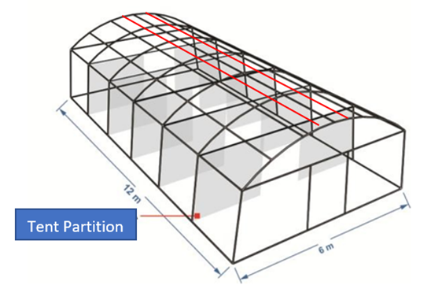

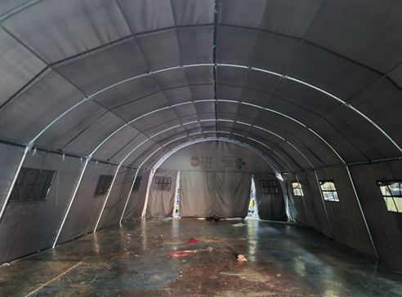

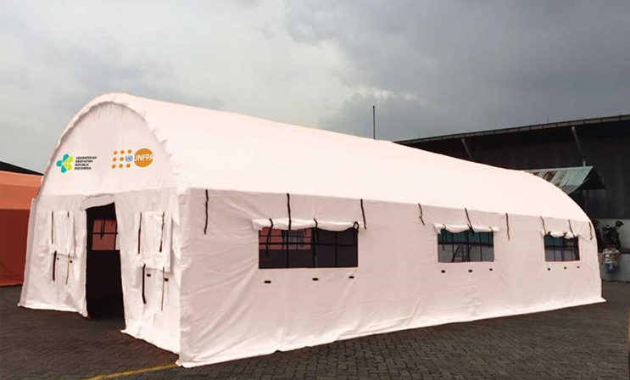

This Request for Quotation is open to all legally-constituted companies that can provide the **Reproductive Health Tent (RH TENT) SIZE 6X12 Meter** and have legal capacity to deliver in the country, or through an authorized representative.

1. **About UNFPA**

UNFPA, the United Nations Population Fund (UNFPA), is an international development agency that works to deliver a world where every pregnancy is wanted, every child birth is safe and every young person’s potential is fulfilled.

UNFPA is the lead UN agency that expands the possibilities for women and young people to lead healthy sexual and reproductive lives. To read more about UNFPA, please go to: <http://pacific.unfpa.org>

**Objective:**

The object of the RFQ is to identify a supplier who can provide UNFPA PSRO with **Reproductive Health Tent (RH TENT) SIZE 6X12**. The selected vendor is expected to provide such products, based on the specific Purchase Orders submitted to the vendor.

1. **Questions**

Questions or requests for further clarifications should be submitted in writing to the contact person below:

|  |  |
| --- | --- |
| Name of contact person at UNFPA: | *Arun Raj* |
| Tel Nº: | *+679 3230747* |
| Fax Nº: | *+679 3312785* |
| Email address of contact person: | [*arraj@unfpa.org*](mailto:arraj@unfpa.org) |

The deadline for submission of questions is Sunday 30 January, 5.00pm, Fiji Time. Questions will be answered in writing and shared with all parties as soon as possible after this deadline.

1. **Content of quotations**

Quotations should be submitted in a single email whenever possible, depending on file size. Quotations must contain:

1. Technical proposal, in response to the requirements outlined in the specifications should comply with:
2. Price quotation, to be submitted strictly in accordance with Price Quotation Form.

Both parts of the quotation must be signed by the company’s relevant authority and submitted in PDF format.

1. **Instructions for submission**

Proposals should be prepared based on the guidelines set forth in Section III above, along with a properly filled out and signed price quotation form, and are to be sent by email to the contact person indicated below no later than: Sunday 30 January, 5.00pm, Fiji Time.

|  |  |
| --- | --- |
| Secure Email address : | [psro.bidding@unfpa.org](mailto:psro.bidding@unfpa.org) |

Please note the following guidelines for electronic submissions:

* The following reference must be included in the email subject line: RFQ Nº UNFPA/FJI/RFQ/22/001- Reproductive Health Tent (RH TENT) Size 6X12 Meter
* Proposals that do not contain the correct email subject line may be overlooked by the procurement officer and therefore not considered.
* The total email size may not exceed **20 MB (including email body, encoded attachments and headers)**. Where the technical details are in large electronic files, it is recommended that these be sent separately before the deadline.
* When submitting electronic offers, Bidders will receive an auto-reply acknowledging receipt of the **first** email. Should you offer require to submit more than one email, in the body of this first email, bidders are requested to list the number of messages, which make up their technical offer and the number of messages, which make up their financial offer. If you do not receive any auto-reply for the first email from UNFPA’s email system, please inform Ram Dahal, Operations and Quality Assurance Analyst at: [dahal@unfpa.org](mailto:dahal@unfpa.org)
* Any quotation submitted will be regarded as an offer by the bidder and does not  
  constitute or imply the acceptance of any quotation by UNFPA. UNFPA is under no obligation to award a contract to any bidder as a result of this RFQ.

1. **Overview of Evaluation Process**

Quotations will be evaluated based on the compliance with the technical specifications and the total cost of the goods (price quote). The evaluation will be carried out in a two-step process by an ad-hoc evaluation panel. Technical proposals will be evaluated for technical compliance prior to the comparison of price quotes.

1. **Award**

In case of a satisfactory result from the evaluation process, UNFPA shall award a Purchase Order to the lowest priced bidder whose bid has been determined to be substantially compliant with the bidding documents.

1. **Right to Vary Requirements at Time of Award**

UNFPA reserves the right at the time of award of Contract to increase or decrease, by up to 20%, the volume of goods specified in this RFQ without any change in unit prices or other terms and conditions.

1. **Payment Terms**

UNFPA payment terms are net 30 days upon receipt of shipping documents, invoice and other documentation required by the contract.

1. [**Fraud and Corruption**](http://www.unfpa.org/about-procurement#FraudCorruption)

UNFPA is committed to preventing, identifying, and addressing all acts of fraud against UNFPA, as well as against third parties involved in UNFPA activities. UNFPA’s Policy regarding fraud and corruption is available here: [Fraud Policy](http://www.unfpa.org/resources/fraud-policy-2009#overlay-context=node/10356/draft). Submission of a proposal implies that the Bidder is aware of this policy.

Suppliers, their subsidiaries, agents, intermediaries and principals must cooperate with the UNFPA Office of Audit and Investigations Services as well as with any other oversight entity authorized by the Executive Director and with the UNFPA Ethics Advisor as and when required.  Such cooperation shall include, but not be limited to, the following: access to all employees, representatives agents and assignees of the vendor; as well as production of all documents requested, including financial records.  Failure to fully cooperate with investigations will be considered sufficient grounds to allow UNFPA to repudiate and terminate the Agreement, and to debar and remove the supplier from UNFPA's list of registered suppliers.

A confidential Anti-Fraud Hotline is available to any Bidder to report suspicious fraudulent activities at [UNFPA Investigation Hotline](http://web2.unfpa.org/help/hotline.cfm).

1. **Zero Tolerance**

UNFPA has adopted a zero-tolerance policy on gifts and hospitality. Suppliers are therefore requested not to send gifts or offer hospitality to UNFPA personnel. Further details on this policy are available here: [Zero Tolerance Policy](http://www.unfpa.org/about-procurement#ZeroTolerance).

1. **RFQ Protest**

Bidder(s) perceiving that they have been unjustly or unfairly treated in connection with a solicitation, evaluation, or award of a contract may submit a complaint to the UNFPA Head of the Business Unit Dr. Jennifer Butler, UNFPA PSRO Director and Representative at butler@unfpa.org. Should the supplier be unsatisfied with the reply provided by the UNFPA Head of the Business Unit, the supplier may contact the Chief, Procurement Services Branch at [procurement@unfpa.org](mailto:procurement@unfpa.org).

1. **Disclaimer**

Should any of the links in this RFQ document be unavailable or inaccessible for any reason, bidders can contact the Procurement Officer in charge of the procurement to request for them to share a PDF version of such document(s).

PRICE Quotation Form

|  |  |
| --- | --- |
| **Name of Bidder:** |  |
| **Date of the quotation:** | Click here to enter a date. |
| **Request for quotation Nº:** | **RFQ Nº UNFPA/FJI/RFQ/22/001** |
| **Currency of quotation:** | FJD |
| **Validity of quotation:**  *(The quotation shall be valid for a period of at least 3 months after the submission deadline.)* |  |

|  |  |  |  |  |  |  |
| --- | --- | --- | --- | --- | --- | --- |
| **Price Quotation Form** | | | | | | |
| Item | Product Name & Description | | UOM | Unit Price | Number of Units | Total  (FJD) |
| 1 | **Reproductive Health Tent (RH TENT) SIZE 6X12 Meter:**  *Specifications:*  Technical Specification  TENT ROOF  Outside : White Color  Inside : Grey/navy blue/similar  Coating Technique : Triple Coating  Coating : to reduce solar heat, water resistant and anti-fungi  Chemical Coating Material  Coating Material : Standard ISO 9001-2008/OEKOTEX  Type of polyester : 100% 450 D  Raw Material of yarn : New material Grade A (not recycle)  Finishing of Yarn : Military Standard  Twist system, light and strong  PLAFON TENDA  Ceiling Material : Satin Polyester, Full tent ceiling  Print logo:  UNFPA and DFAT above the front and rear entrances  MAIN FRAME  Material : Black Pipe/Galvanized or equivalent and coating  Load resistance : Not easy to break/crack  Pipe type : Unreinforced pipe  Construction  a. Main Pipe (pole) : Pipe  - Diameter,mm : 45  - Thickness,mm : 1.2  - Length (main pole),mm : 1800  - Quantity,bar : 14  b. Base pipe  - Outside Diameter, mm : 45  - Thick, mm : 1.2  - Length, mm : 1800  - Quantity, bar : 12  c. Connecting of Main Pole  - Outside Diameter, mm : 40  - Thick, mm : 1.2  - Length, mm : 1800    Technical Specification  - Quantity, bar : 12  d. Roof Frame, Curved Pipe  - Outside Diameter, mm : 40  - Thick, mm : 1.2  - Length, mm : 2800  - Quantity, bar : 21  e. Roof Connecting Pipe  - Outside Diameter, mm : 40  - Thick, mm : 1.2  - Length, mm : 1900  - Quantity, bar : 54  f. Connector, L type (Edge Base)  - Outside Diameter, mm : 45  - Thick, mm : 1.2  - Whole pipe length, mm : 400  - Outside pipe length, mm : 100 X 2  - Inlet pipe length, mm : 100 X 2  - Quantity, socket : 4  g. Connector, T type  - Outside Diameter, mm : 45  - Thick, mm : 1.2  - Whole pipe length, mm : 600  - Outside pipe length, mm : 100 X 3  - Inlet pipe length, mm : 100 X 3  - Quantity, socket : 6  h. Connector, Y type (Edge Roof Frame)  ( Kaki Tiga )  - Outside Diameter, mm : 40  - Thick, mm : 1.2  - Whole pipe length, mm : 900  - Outside pipe length, mm : 100 X 4  - Inlet pipe length, mm : 100 X 3  - Quantity, socket : 4  i. Middle roof truss (Four Legs)  - Outside Diameter, mm : 40  - Thick, mm : 1.2  - Whole pipe length, mm : 900  - Outside pipe length, mm : 100 X 4  - Inlet pipe length, mm : 100 X 3  - Quantity, socket : 10  PEGS  Fishing rod type  Material : Steel Concrete  Basic Shape : Round  Construction  a. Diameter, mm : 8  b. Length, mm : 300  c. Part of bends, mm : 50  d. Straight part : 250  U Shape  Material : Steel Concrete  Design : Round  a. Diameter, mm : 12  b. Length, mm : 500  c. Part of bends, mm : 10  d. Straight part : 400  D SHAPE  Raw Material : Iron    Technical Specification  Accessories : Pernekel  Design  - Outside Diameter, mm : 20  ZIPPERS  Material : Polyester 100%  - Length, mm : 220 x 4  - Width, mm : 30  - Number : 30  ZIPPER HEAD  Material : Iron  - Color : Black  - Metal Finish : Pernekel  - Number : 10  WEBING TAPE  Binding Tape  a. Material : Polyester 100%  b. Width, mm : min 150  c. Color : Black  TENT PARTITION  Material : PVC Asian Power 550gsm or equivalent  Size : 300cm x 200cm  Distance : at each 200cm  WEBING TAPE  Binding Tape  Material : Polyester 100 %  Width, mm : min 100  Color : Black  SEWING THREAD  Sewing Tread Nr. 24  - Material : Nylon 100%  - Number : 24  - Color : Black  SEWING TECHNICAL  Using chemical water resistant : cover the stitches with a silicone that compound with cloth  Strong sewing with SNI/Military standard  : Using a special sewing machine for thick material.  Stitching strength standard : Item Code 11244-3021  Military-standard stitching : Stitching requirement:  1. Stitch density is 3-4 stiches per cm  2. The stitches must be straight, the tension of sewing is balanced and shouldn’t be jump    Technical Specification  WELDING TECHNICAL  Standard of Quality : weld around the pipe  Strength and Resistance : using welding wire which stronger and more sticking of welding result  PAINTING TECHNIQUE  Quality Standard : Anti-rust painting  Paint Durability and Quality : Good sticking of Paint and using thinner type A  Painting Technology : Using Spray gun and Compressor so that the paint more sticks to the pipe  TENT BASE  Material of base : Plastic tarpaulin size 6 m x 12 m  PACKING : Crate Wooden box/thick multiplex, strong material is not easy breakable, durable, there is distance for loading and unloading using a forklift. It is possible to stack 1 set  in pairs (top-down) to save space storage.  Length, cm : + 213  Width, cm : + 50  High, cm : + 60 | | Sets |  | 10 |  |
| 2 | Delivery Charges based on the following 2010 Incoterm, to: | DAP | Estimated Delivery Date:  _____________________ | | |  |
| **UNFPA Pacific Sub-Regional Office Level 6, Kadavu House,**  **414 Victoria Parade,**  **Suva, Fiji Islands** | |
| GRAND TOTAL (for the supply of 10 x RH Tent) FJD$ | | | | | |  |

*Vendor’s Comments:*

I hereby certify that the company mentioned above, which I am duly authorized to sign for, has reviewed RFQ UNFPA/FJI/RFQ/22/001 including all annexes, amendments to the RFQ document (if applicable) and the responses provided by UNFPA on clarification questions from the prospective service providers. Further, the company accepts the General Conditions of Contract for UNFPA and we will abide by this quotation until it expires.

|  |  |  |
| --- | --- | --- |
|  | Click here to enter a date. |  |
| Name and title | Date and place | |

**ANNEX I:**

**General Conditions of Contracts:**

**De Minimis Contracts**

This Request for Quotation is subject to UNFPA’s General Conditions of Contract: De Minimis Contracts, which are available in: [English,](http://www.unfpa.org/resources/unfpa-general-conditions-de-minimis-contracts) [Spanish](http://www.unfpa.org/sites/default/files/resource-pdf/UNFPA%20General%20Conditions%20-%20De%20Minimis%20Contracts%20SP_0.pdf) and [French](http://www.unfpa.org/sites/default/files/resource-pdf/UNFPA%20General%20Conditions%20-%20De%20Minimis%20Contracts%20FR_0.pdf)