04 March 2025

**REQUEST FOR QUOTATION - EXTENSION**

**RFQ Nº UNFPA/FJI/RFQ/25/003**

Dear Sir/Madam,

UNFPA hereby solicits your quotation for **“Supply and delivery of Used 40ft Shipping Container”,** for UNFPA Country Office – Vanuatu.

**Specifications**:

|  |  |  |
| --- | --- | --- |
| **No.** | **Description** | **Quantity** |
| 1 | Supply and delivery of Used 40ft Shipping Container   * 1 x Vanuatu | 1 |

This Request for Quotation is open to all legally constituted companies that can provide the requested items and have legal capacity to deliver in the countries Vanuatu or through an authorized representative.

**Eligibility for this RFQ is limited to companies conducting business in Vanuatu.**

**The Specifications are as follows: (Bidders can bid for the same or equivalent to the specifications). Either option will be selected based on best value for money.**

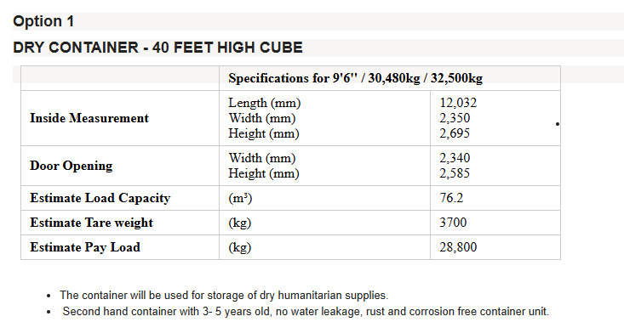

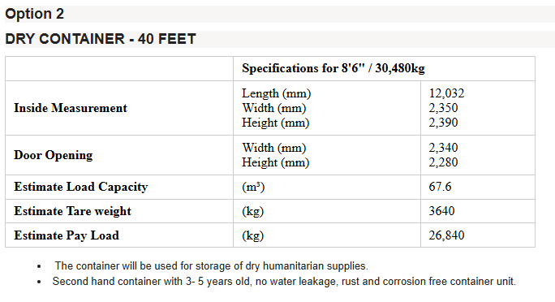

**I.** **About UNFPA**

UNFPA, the United Nations Population Fund (UNFPA), is an international development agency that works to deliver a world where every pregnancy is wanted, every childbirth is safe and every young person’s potential is fulfilled.

UNFPA is the lead UN agency that expands the possibilities for women and young people to lead healthy sexual and reproductive lives. To read more about UNFPA, please go to: [http://pacific.unfpa.org](http://pacific.unfpa.org/)

**Objective:**

The object of the RFQ is to identify a supplier who can provide UNFPA PSRO with the above-mentioned items as per the requirement. The selected vendor is expected to provide such products, based on the specific Purchase Orders submitted to the vendor.

**II.** **Questions**

Questions or requests for further clarifications should be submitted in writing to the contact person below:

|  |  |
| --- | --- |
| Name of contact person at UNFPA: | *Ashika Mishra* |
| Email address of contact person: | [*amishra@unfpa.org*](mailto:amishra@unfpa.org) |

**The deadline for submission of questions is Tuesday 25 February 2025, 5.00pm, Fiji Time. Questions will be answered in writing and shared with all parties as soon as possible after this deadline.**

**III.** **Eligible Bidders**

This Request for Quotation is open to all eligible bidders; to be considered an eligible bidder for this solicitation process you must comply with the following:

● A bidder must be a legally constituted company that can provide the requested products and have legal capacity to enter into a contract with UNFPA to deliver in the country, or through an authorized representative.

(Eligibility for this RFQ is limited to companies conducting business in Vanuatu.)

● A bidder must not have a conflict of interest regarding the solicitation process or with the TORs / Technical Specifications. Bidders found to have a conflict of interest shall be disqualified.

● At the time of Bid submission, the bidder, including any JV/Consortium members, is not under procurement prohibitions derived from the [Compendium of United Nations Security Council Sanctions Lists](https://www.un.org/securitycouncil/content/un-sc-consolidated-list) and has not been suspended, debarred, sanctioned or otherwise identified as ineligible by any [UN Organization](http://www.ungm.org/) or the [World Bank Group](https://www.worldbank.org/en/about/corporate-procurement/business-opportunities/non-responsible-vendors).

● Bidders must adhere to the UN Supplier Code of Conduct, which may be found by clicking on [UN Supplier Code of Conduct](http://www.un.org/Depts/ptd/pdf/conduct_english.pdf).

**IV.** **Content of quotations**

Quotations should be submitted in a single email whenever possible, depending on file size. Quotations must contain:

a) The bidder shall be required to quote for all items in response to the requirements outlined in the specifications.

b) Signed Declaration Form, to be submitted strictly in accordance with the document.

c) Price quotation, to be submitted strictly in accordance with the price quotation form.

Both parts of the quotation must be signed by the company’s relevant authority and submitted in PDF format.

**V.** **Instructions for submission**

Proposals should be prepared based on the guidelines set forth in Section IV above, along with a properly filled out and signed price quotation form and are to be sent by email to the contact person indicated below no later than: **Wednesday 19 March 2025 at 5:00 PM Fiji Time**.

|  |  |
| --- | --- |
| Secure email address: | [psro.bidding@unfpa.org](mailto:psro.bidding@unfpa.org) |

Please note the following guidelines for electronic submissions:

● The following reference must be included in the email subject line: **RFQ Nº UNFPA/FJI/RFQ/25/003 – Supply and delivery of Used 40ft Shipping Container,** in Vanuatu**.** Proposals that do not contain the correct email subject line may be overlooked by the procurement officer and therefore not considered.

● The total email size may not exceed **20 MB (including email body, encoded attachments and headers)**. Where the technical details are in large electronic files, it is recommended that these be sent separately before the deadline.

● Any quotation submitted will be regarded as an offer by the bidder and does not constitute or imply acceptance of the quotation by UNFPA. UNFPA is under no obligation to award a contract to any bidder as a result of this RFQ.

**VI.** **Overview of Evaluation Process**

Quotations will be evaluated based on the compliance with the technical specifications and the total cost of the goods (as per price quote).

The evaluation will be carried out in a two-step process by an ad-hoc evaluation panel. Technical proposals will be evaluated for technical compliance prior to the comparison of price quotes.

**VII.** **Award**

In case of a satisfactory result from the evaluation process, UNFPA shall award a Purchase Order to the lowest priced bidder whose bid has been determined to be substantially compliant with the bidding documents.

**VIII.** **Right to Vary Requirements at Time of Award**

UNFPA reserves the right at the time of award of Contract to increase or decrease, by up to 20%, the volume of goods specified in this RFQ without any change in unit prices or other terms and conditions.

**IX.** **Payment Terms**

UNFPA payment terms are net 30 days upon receipt of shipping documents, invoice and other documentation required by the contract.

**X.**  [**Fraud and Corruption**](http://www.unfpa.org/about-procurement#FraudCorruption)

UNFPA is committed to preventing, identifying, and addressing all acts of fraud against UNFPA, as well as against third parties involved in UNFPA activities. UNFPA’s Policy regarding fraud and corruption is available here:  [Fraud Policy](https://www.unfpa.org/sites/default/files/admin-resource/Eths_Fraud_policy.pdf). Submission of a proposal implies that the Bidder is aware of this policy.

Suppliers, their subsidiaries, agents, intermediaries and principals must cooperate with the UNFPA Office of Audit and Investigations Services as well as with any other oversight entity authorized by the Executive Director and with the UNFPA Ethics Advisor as and when required. Such cooperation shall include, but not be limited to, the following: access to all employees, representatives agents and assignees of the vendor; as well as production of all documents requested, including financial records. Failure to fully cooperate with investigations will be considered sufficient grounds to allow UNFPA to repudiate and terminate the Agreement, and to debar and remove the supplier from UNFPA's list of registered suppliers.

A confidential Anti-Fraud Hotline is available to any Bidder to report suspicious fraudulent activities at [UNFPA Investigation Hotline](http://web2.unfpa.org/help/hotline.cfm).

**XI.** **Zero Tolerance**

UNFPA has adopted a zero-tolerance policy on gifts and hospitality. Suppliers are therefore requested not to send gifts or offer hospitality to UNFPA personnel. Further details on this policy are available here: [Zero Tolerance Policy](http://www.unfpa.org/about-procurement#ZeroTolerance).

**XII.** **RFQ Protest**

Bidder(s) perceiving that they have been unjustly or unfairly treated in connection with a solicitation, evaluation, or award of a contract may submit a complaint to the UNFPA Head of the Business Unit Dr Mateen Shaheen, Deputy Director and Deputy Representative (OIC) at [shaheen@unfpa.org](mailto:shaheen@unfpa.org). Should the supplier be unsatisfied with the reply provided by the UNFPA Head of the Business Unit, the supplier may contact the Chief, Supply Chain Management Unit at [supplychain@unfpa.org](mailto:supplychain@unfpa.org).

**XIII.** **Disclaimer**

Should any of the links in this RFQ document be unavailable or inaccessible for any reason, bidders can contact the Procurement Officer in charge of the procurement to request for them to share a PDF version of such document(s).

**DECLARATION FORM**

The undersigned, being a duly authorized representative of the Company represents and declares that:

|  |  |  |  |
| --- | --- | --- | --- |
| 1. | The Company and its Management[1] have not been found guilty pursuant to a final judgment or a final administrative decision of any of the following: | YES | NO |
|  | 1. Fraud; | ☐ | ☐ |
|  | 1. Corruption; | ☐ | ☐ |
|  | 1. conduct related to a criminal organization; | ☐ | ☐ |
|  | 1. money laundering or terrorist financing; | ☐ | ☐ |
|  | 1. terrorist offences or offences linked to terrorist activities; | ☐ | ☐ |
|  | 1. sexual exploitation and abuse; | ☐ | ☐ |
|  | 1. child labour, forced labour, human trafficking; or | ☐ | ☐ |
|  | 1. irregularity (non-compliance with any legal or regulatory requirement applicable to the Organization or its Management). | ☐ | ☐ |
| 2. | The Company and its Management have not been found guilty pursuant to a final judgment or a final administrative decision of grave professional misconduct. | ☐ | ☐ |
| 3. | The Company and its Management are not: bankrupt, subject to insolvency or winding-up procedures, subject to the administration of assets by a liquidator or a court, in an arrangement with creditors, subject to a legal suspension of business activities, or in any analogous situation arising from a similar procedure provided for under applicable national law. | ☐ | ☐ |
| 4. | The Company and its Management have not been the subject of a final judgment or a final administrative decision finding them in breach of their obligations relating to the payment of taxes or social security contributions. | ☐ | ☐ |
| 5. | The Company and its Management have not been the subject of a final judgment or a final administrative decision which found they created an entity in a different jurisdiction with the intent to circumvent fiscal, social or any other legal obligations in the jurisdiction of its registered office, central administration, or principal place of business (*creating a shell company*). | ☐ | ☐ |
| 6. | The Company and its Management have not been the subject of a final judgment or a final administrative decision which found the Company was created with the intent referred to in point (5) (*being a shell company*). | ☐ | ☐ |

The UNFPA reserves the right to disqualify the Company, suspend or terminate any contract or other arrangement between the UNFPA and the Company, with immediate effect and without liability, in the event of any misrepresentation made by the Company in this Declaration.

It is the responsibility of the Company to immediately inform the UNFPA of any changes in the situations declared above.

This Declaration is in addition to, and does not replace or cancel, or operate as a waiver of, any terms of contractual arrangements between the UNFPA and the Company.

|  |  |
| --- | --- |
| Signature: |  |
| Date: |  |
| Name and Title: |  |
| Name of the Company: |  |
| RFQ Nº: |  |
| Postal Address: |  |
| Email: |  |

**PRICE Quotation Form**

|  |  |
| --- | --- |
| **Name of Bidder:** |  |
| **Date of the quotation:** | Click here to enter a date. |
| **Request for quotation Nº:** | UNFPA/FJI/RFQ/25/003 |
| **Currency of quotation:** | VUV |
| **Validity of quotation:**  *(The quotation shall be valid for a period of at least 3 months after the submission deadline.)* |  |

|  |  |  |  |  |  |  |  |  |  |  |  |  |  |  |  |  |  |  |  |  |  |  |  |  |  |  |  |  |  |  |  |  |  |  |  |  |  |  |  |  |  |  |  |  |
| --- | --- | --- | --- | --- | --- | --- | --- | --- | --- | --- | --- | --- | --- | --- | --- | --- | --- | --- | --- | --- | --- | --- | --- | --- | --- | --- | --- | --- | --- | --- | --- | --- | --- | --- | --- | --- | --- | --- | --- | --- | --- | --- | --- | --- |
| |  |  |  |  |  |  |  | | --- | --- | --- | --- | --- | --- | --- | | **Price Quotation Form** | | | | | | | | Item | Product Name & Description | | UOM | Unit Price | Number of Units | Total  (VUV) | | 1 | Supply and delivery of Used 40Ft Shipping Container | | ea. |  | 1 |  | |  | Delivery Charges with Vanuatu (if applicable) | | ea. |  | 1 |  | | 15 | Delivery Charges based on the following 2020 Incoterm, to: | Choose an item. |  |  |  |  | |  | | | **GRAND TOTAL(VIP)** | | | | | |  |  * Quoted rate must be inclusive of all taxes and charges |



I hereby certify that the company mentioned above, which I am duly authorized to sign for, has reviewed **RFQ UNFPA/FJI/RFQ/25/003** including all annexes, amendments to the RFQ document (if applicable) and the responses provided by UNFPA on clarification questions from the prospective service providers. Further, the company accepts the General Conditions of Contract for UNFPA, and we will abide by this quotation until it expires.

|  |  |  |
| --- | --- | --- |
|  | Click here to enter a date. |  |
| Name and title | Date and place | |

**ANNEX I:**

**General Conditions of Contracts:**

**De Minimis Contracts**

This Request for Quotation is subject to UNFPA’s General Conditions of Contract: De Minimis Contracts, which are available in: [English,](http://www.unfpa.org/resources/unfpa-general-conditions-de-minimis-contracts) [Spanish](http://www.unfpa.org/sites/default/files/resource-pdf/UNFPA%20General%20Conditions%20-%20De%20Minimis%20Contracts%20SP_0.pdf) and [French](http://www.unfpa.org/sites/default/files/resource-pdf/UNFPA%20General%20Conditions%20-%20De%20Minimis%20Contracts%20FR_0.pdf)

[1] “Management” means any person having powers of representation, decision-making or control over the Organization. This may include, for example, executive management and all other persons holding downstream managerial authority, anyone on the board of directors, and controlling shareholders.